Naresh Kalluri (10755799)

Intro to Data Science (CSC 346 D01 Spring 2022).

Assignment – 1 (Project 2).

Date: 2-15-2022.

GitHub Repository: <https://github.com/nk755799/IDS>

Project 2:

Problem 1:

The dataset **USArrests.csv** contains statistics in arrests per 100,000 residents for assault and murder, in each of the 50 US states, in 1973. Also given is the percentage of the population living in urban areas: [https://github.com/bforoura/IDS/tree/main/HW2 (Links to an external site.)](https://github.com/bforoura/IDS/tree/main/HW2)

Excel:

Purpose of the Project:

To prepare the dataset for analysis by using the pre-processing Techniques.

Operations:

A. By seeing the data, it can prove that there are some missing values in the data. The one missing value I found on that data is that Georgia doesn’t have the Assault value.

By using the Mean(average) I can get that value, so I took the whole column for Mean and I got the value = 166. so, I placed 166 as the Assault value for the state of Georgia.

Result:

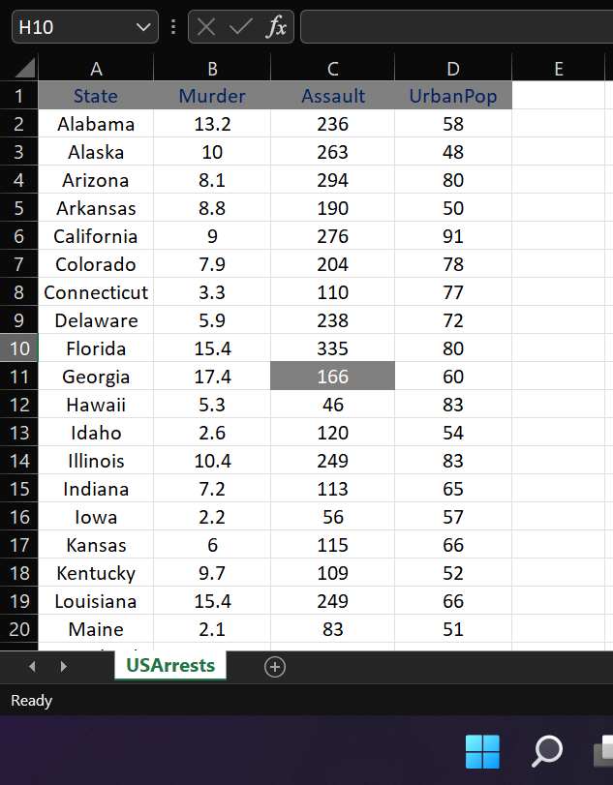

B. There is only one missing value is there and I fixed that too.

C. Plot Murder rates for all 50 states.

Result: For clearly view Please refer to my GitHub repository HW2 Folder

D. Plot histogram of assaults:

Result:

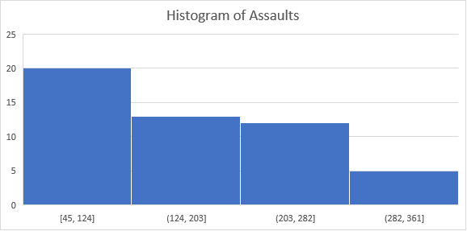

E. Plot Murder rate vs. Assault rate.

Result:

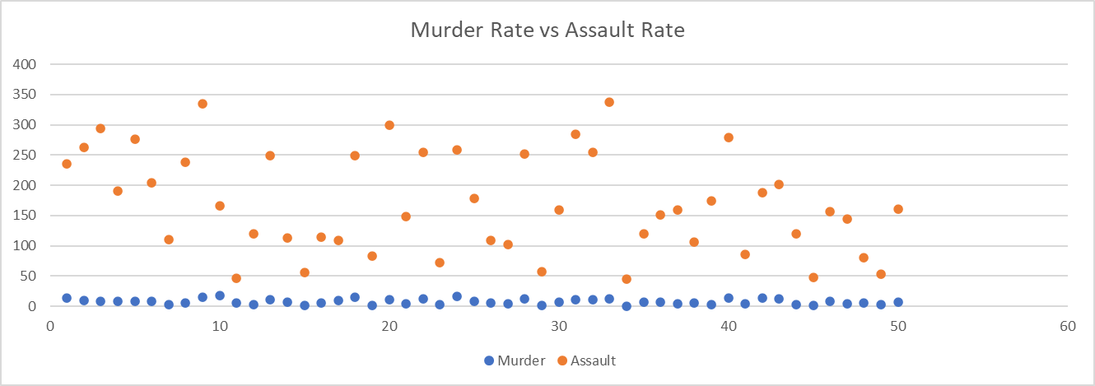

F. Prepare the dataset to establish a relationship between an urban population category and a crime type.

I converted the urban population into categories like Small, Medium, Large and Extra Large and got a relation.

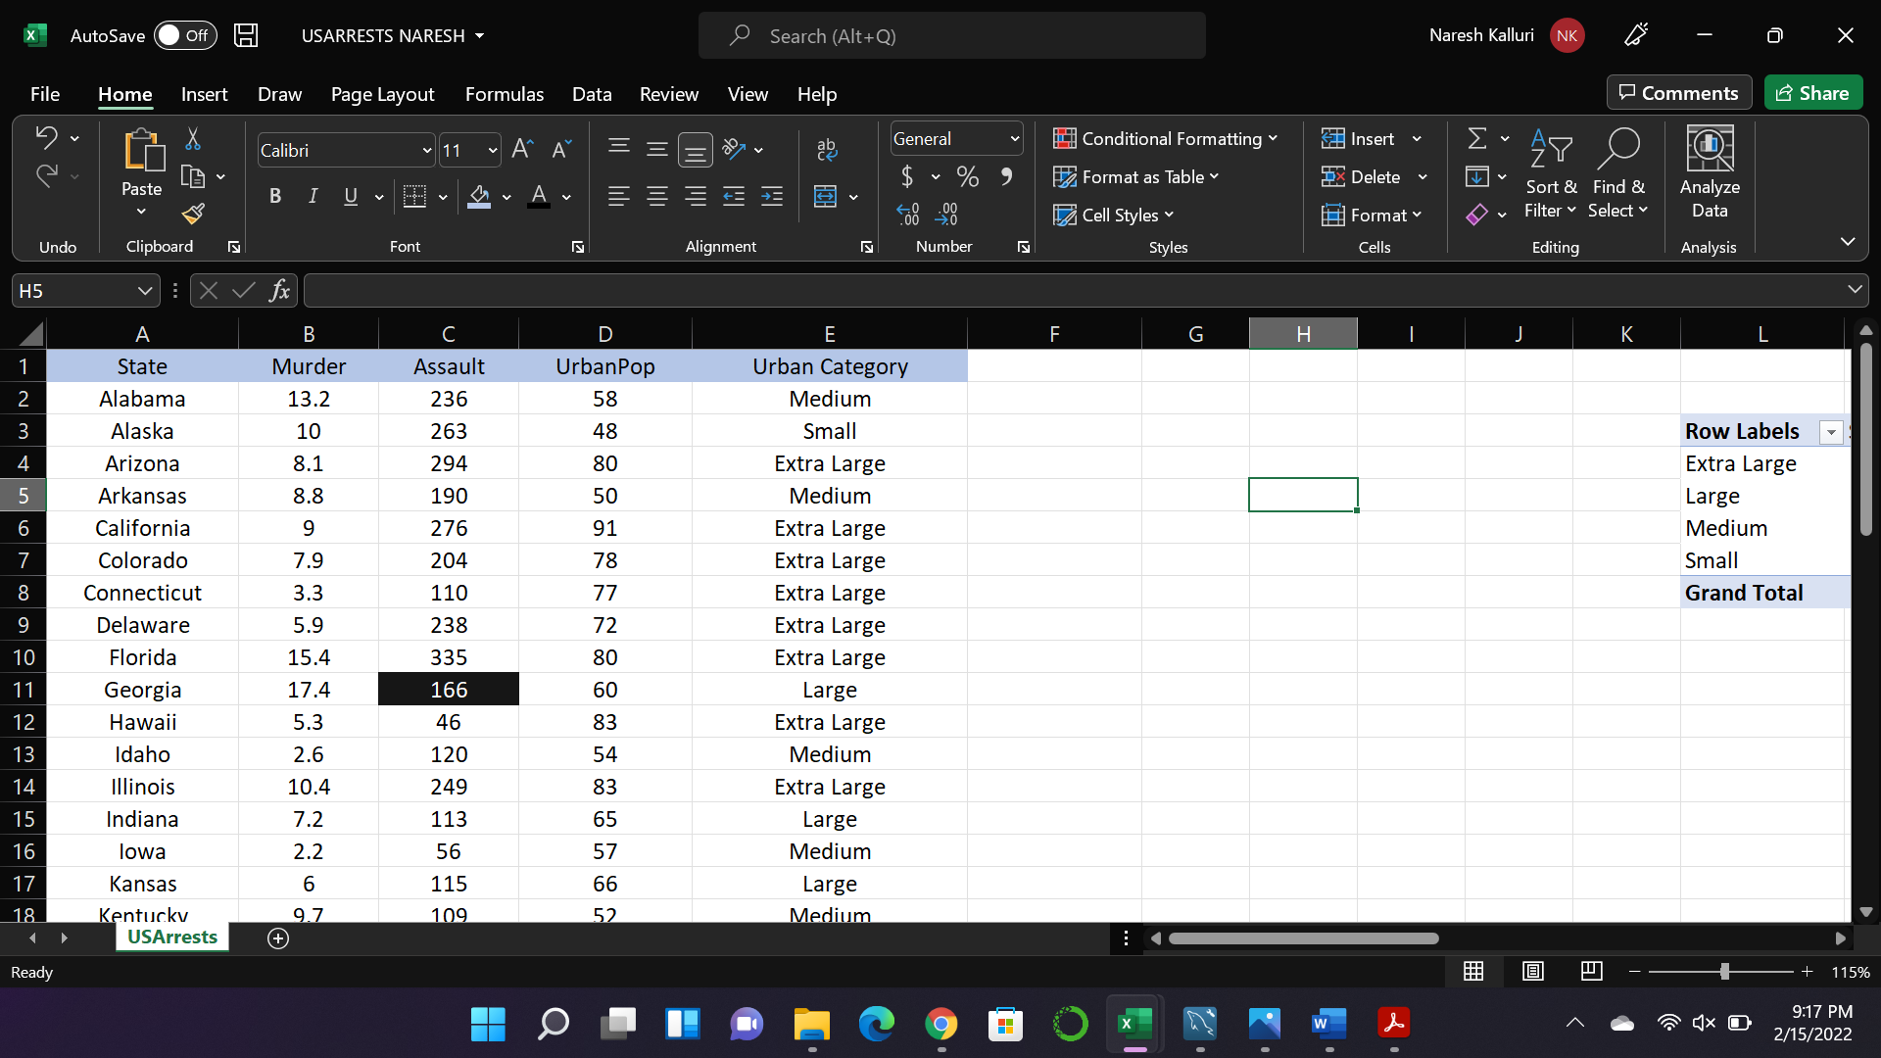

|  |  |  |  |
| --- | --- | --- | --- |
| **Row Labels** | **Sum of Murder** | **Sum of Assault** | **Count of UrbanPop** |
| Extra Large | 169.8 | 4150 | 21 |
| Large | 93.7 | 1797 | 12 |
| Medium | 59.9 | 1148 | 9 |
| Small | 66 | 1398 | 8 |
| **Grand Total** | **389.4** | **8493** | **50** |

MySQL:

A. Import the original CSV file into MySQL and create the table USArrests.

Result: Imported the original CSV file into MySQL workspace and created the table USArrests.

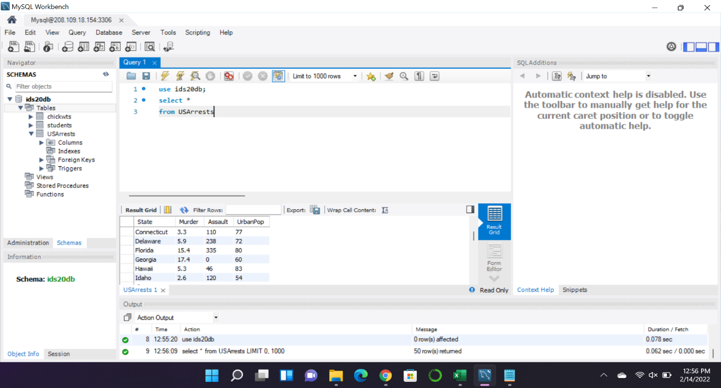

B. Use SQL to replace all missing values in a column by the average. Hint: Use the Update command.

Result:

First I took the average method to get the value of the missing Assault value of the state of Georgia. 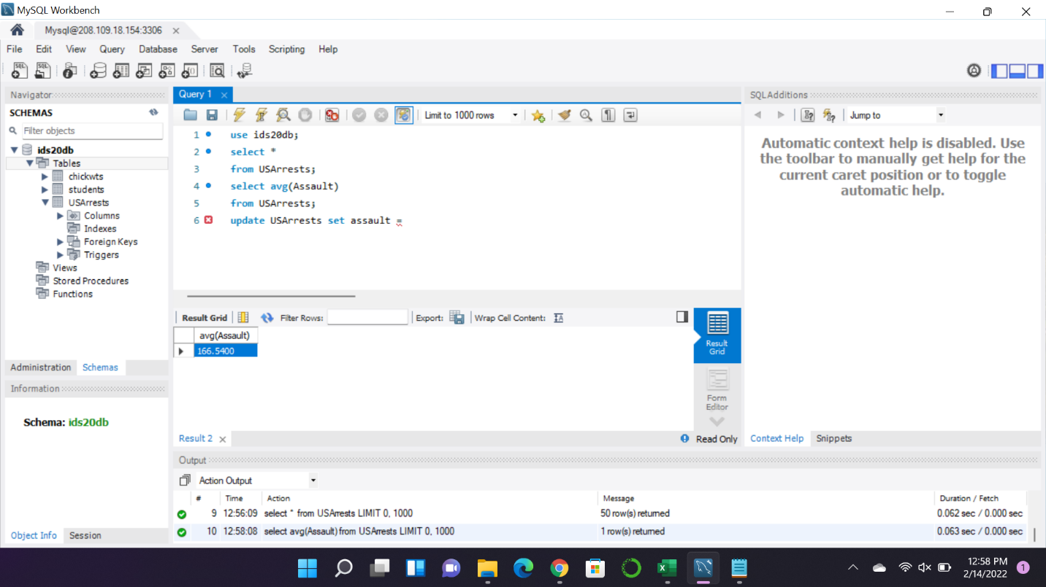

Next used the Update command to update the Georgia Assault Value with an average of column ’166.54’

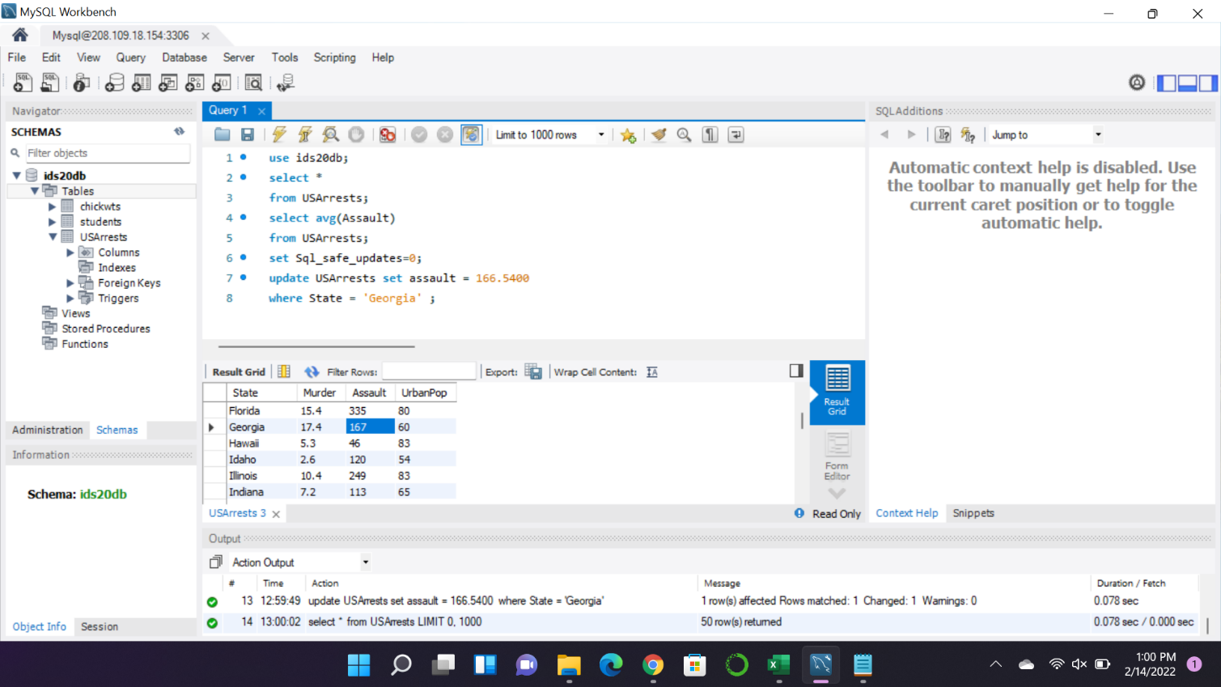

C. Find min, max, mean, and variance of all numeric attributes in SQL.

Result: For Murder:

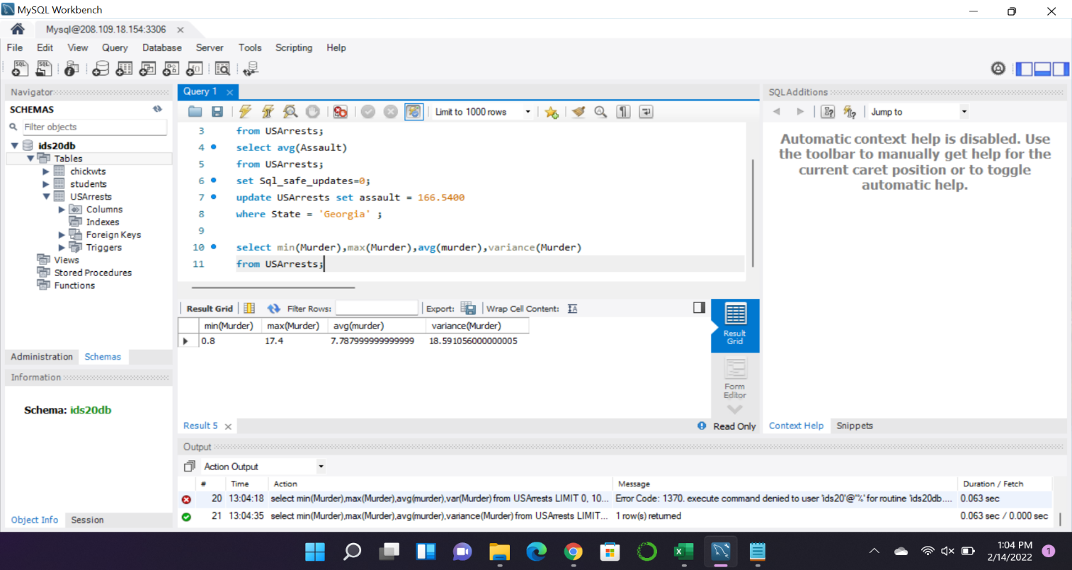

For Assaults:

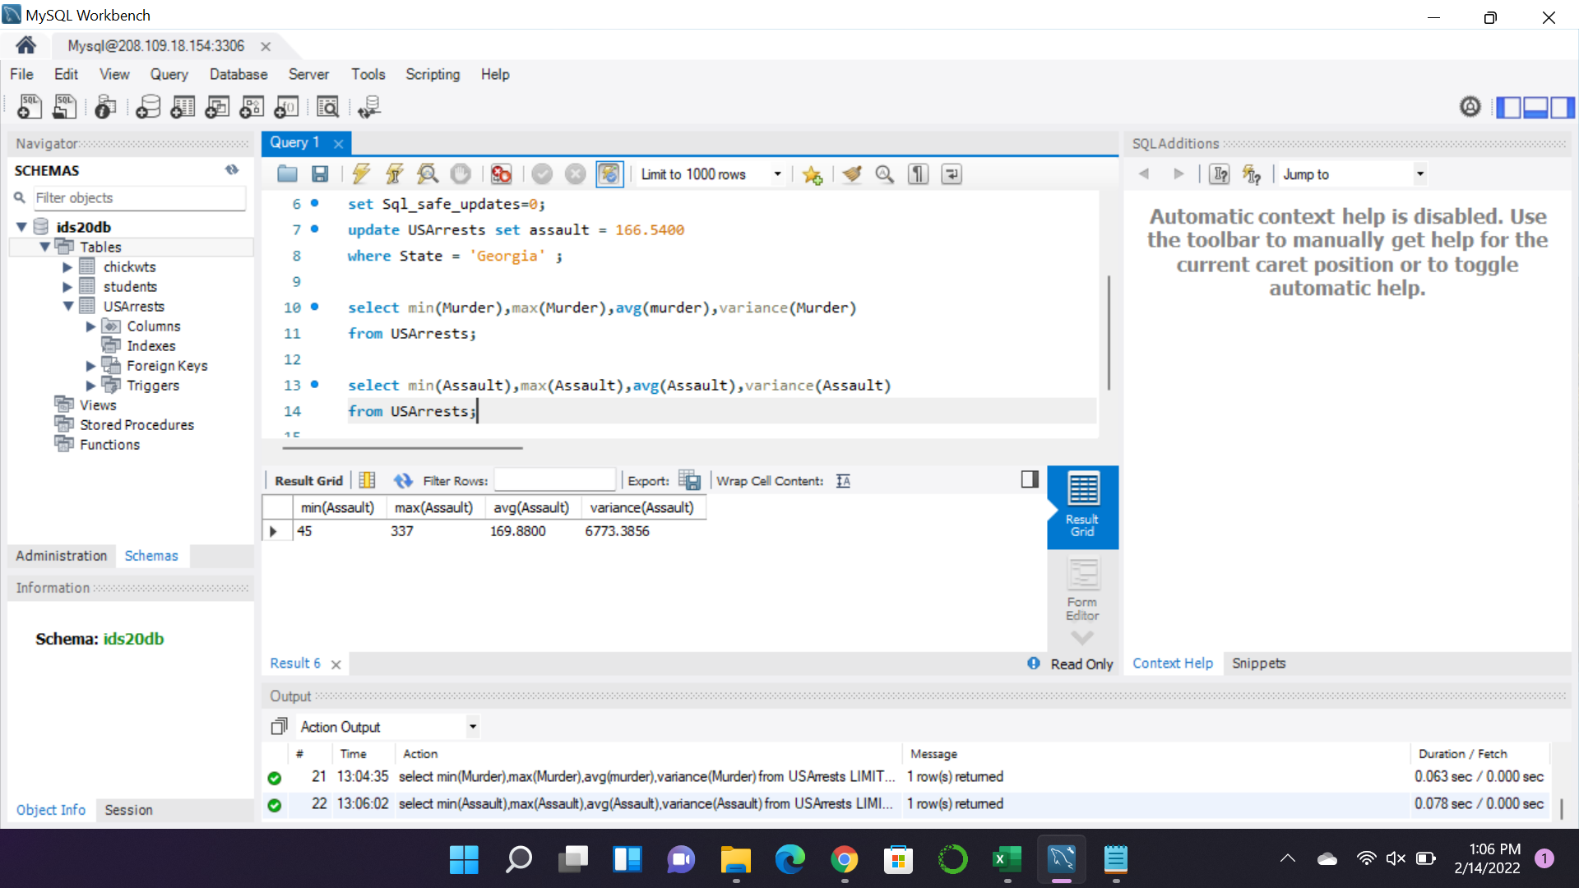

For Urban Population

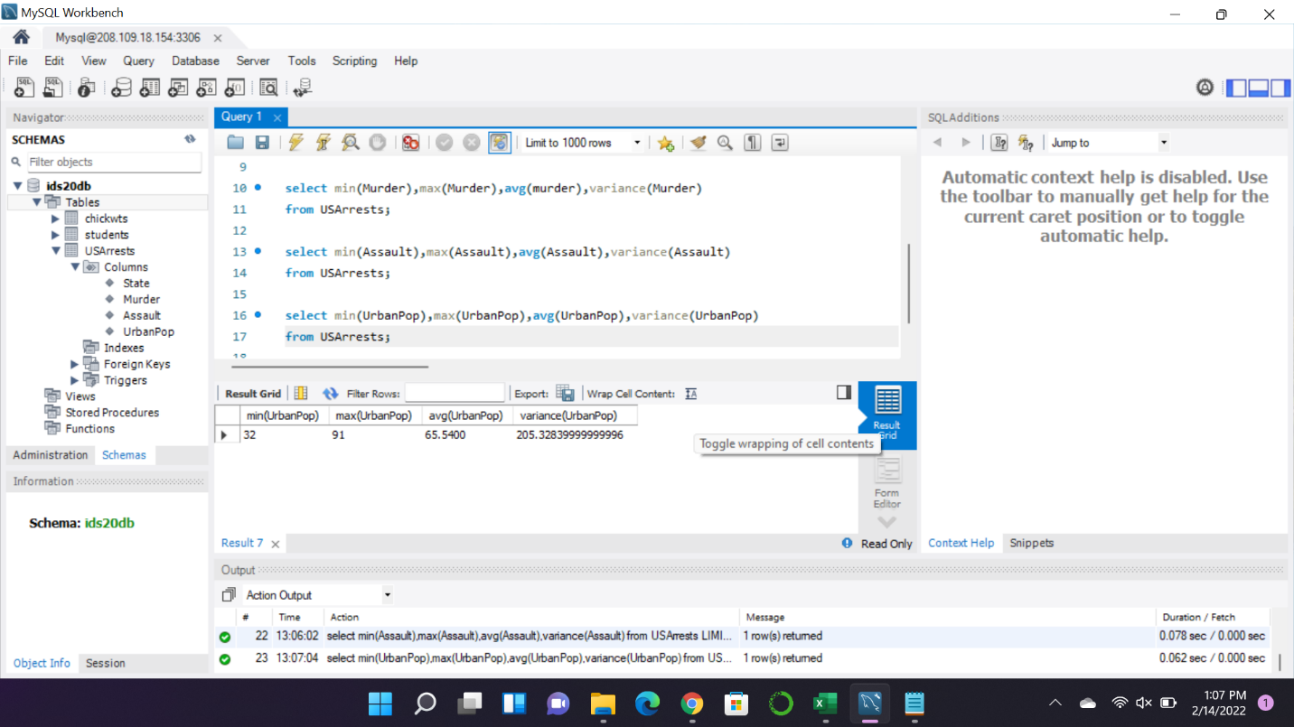

D. Which state has the maximum murder rate?

Result:

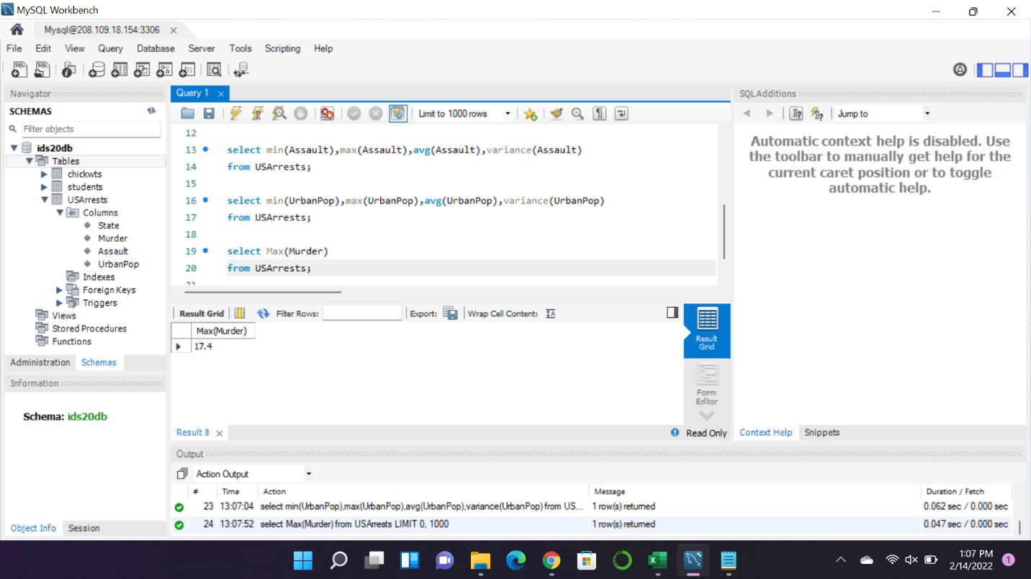

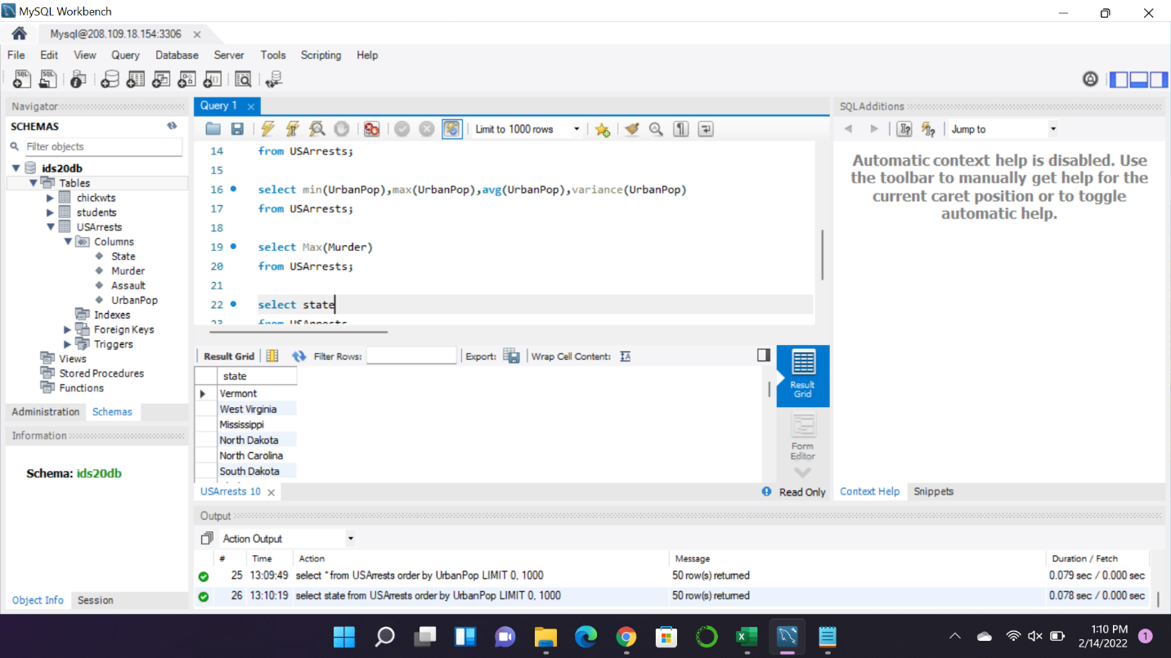

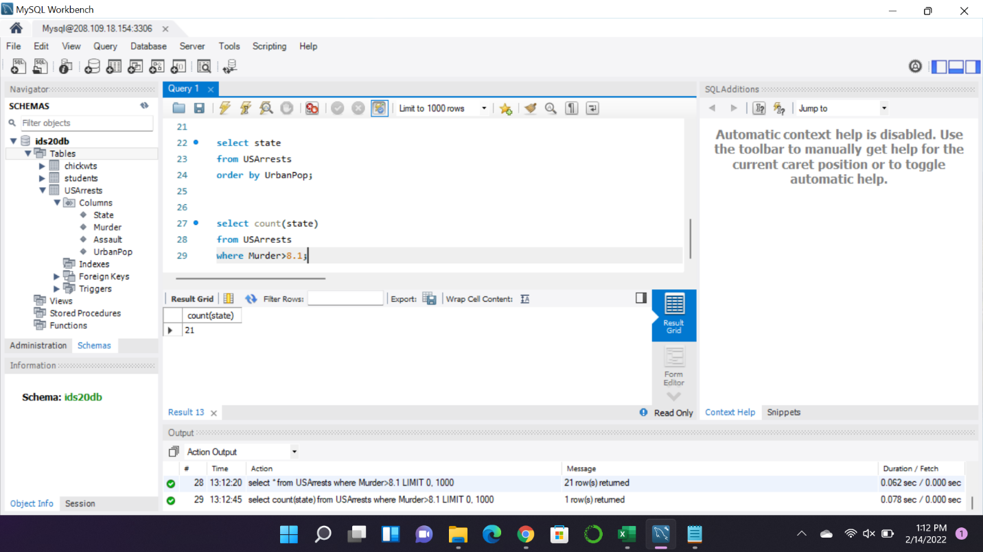

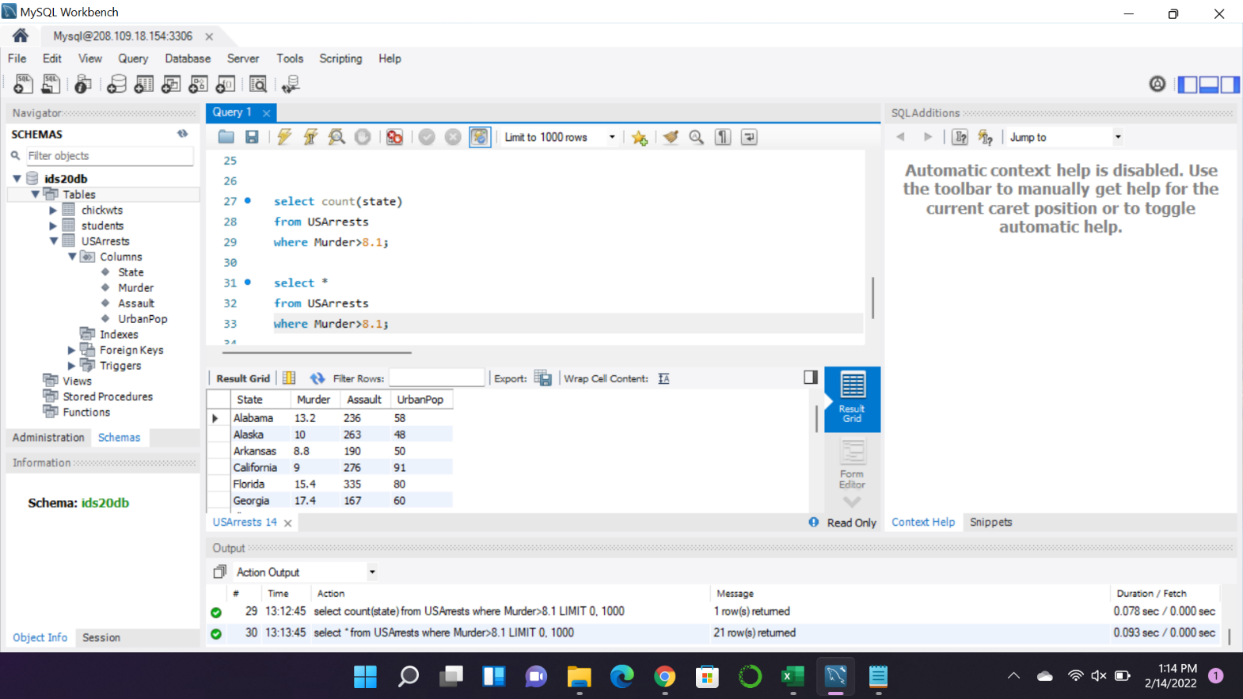

Problem 2:

Excel:

Purpose of the Project:

To prepare the dataset for analysis by using the pre-processing Techniques.

Operations:

* First took the Child mortality rate file in the professor Github Repository <https://github.com/bforoura/IDS/tree/main/HW2>.
* Imported the data into the Excel worksheet but I found several missing values in the data, and I applied the average method for every respective column to get the Mean values and I placed those values in place of the missing value for their respective columns.

Below are the result after updating the missing values of the data

B. Under-ﬁve mortality rate and neonatal mortality rate.

Infant mortality rate and neonatal mortality rate.

Year and infant mortality rate.

Categoric relation between every attribute in the data.

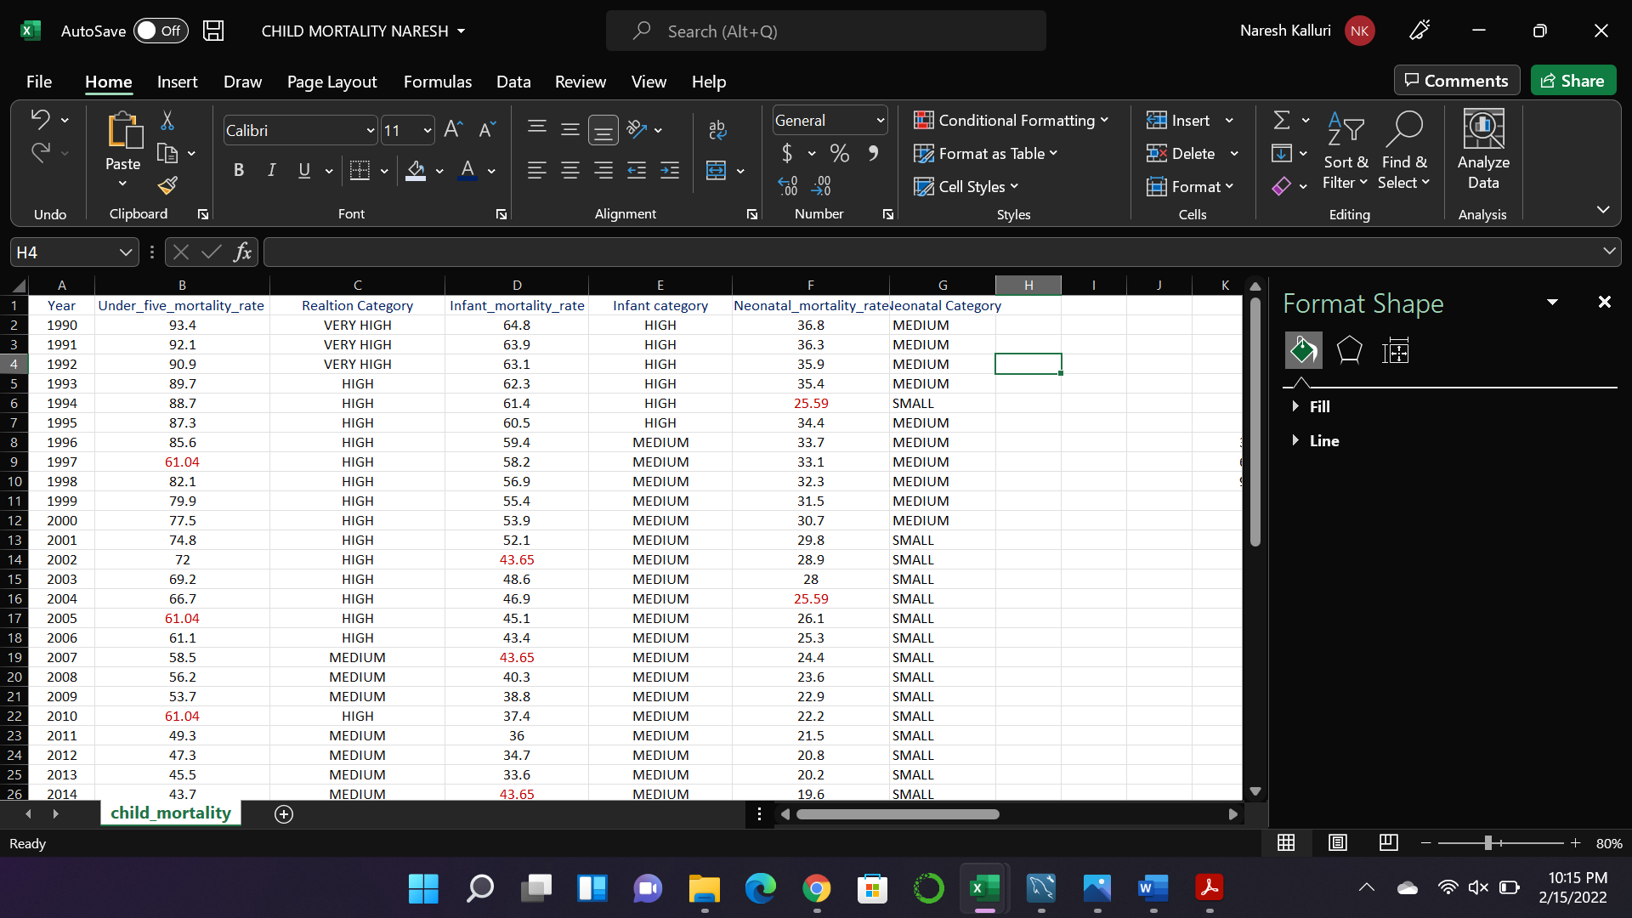

MySQL:

A. Import the original data set into MySQL:

Result: Imported the original data set into the MySQL workspace successfully.

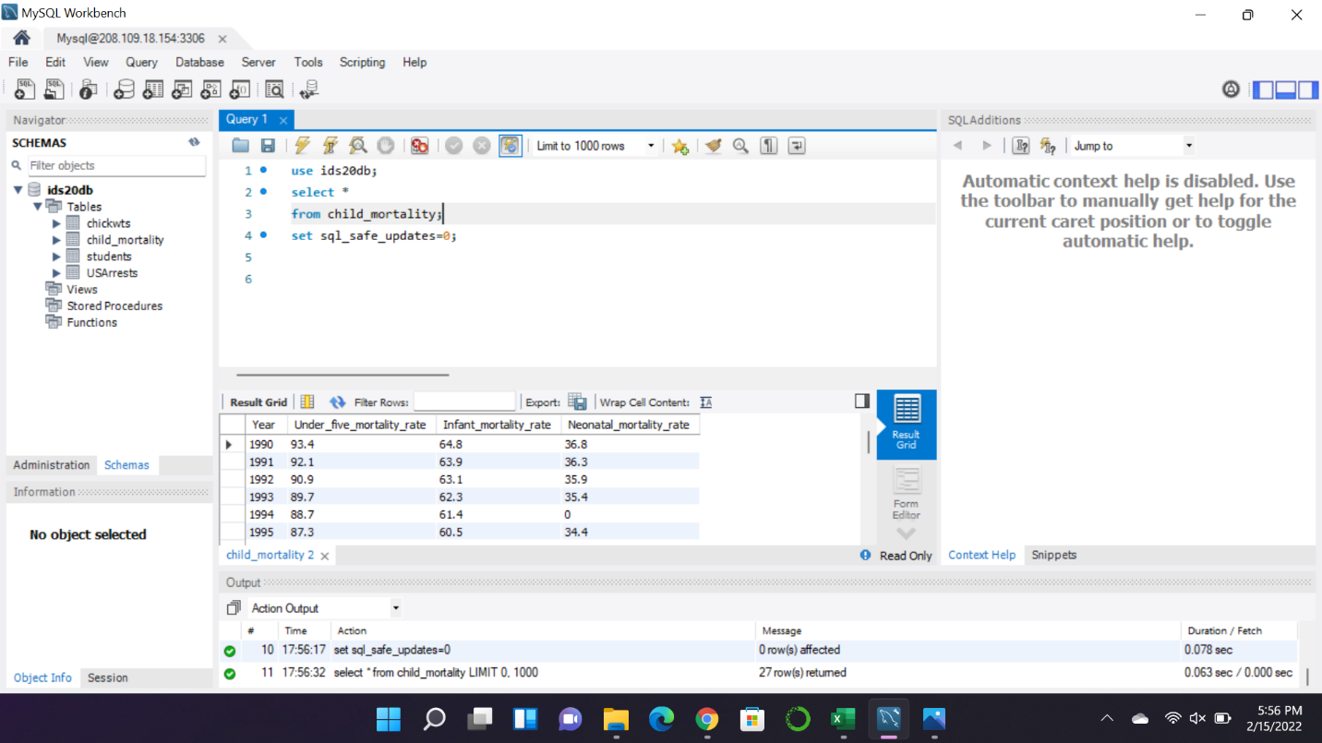

B. Use SQL to fill in the missing values in each column using the medians.

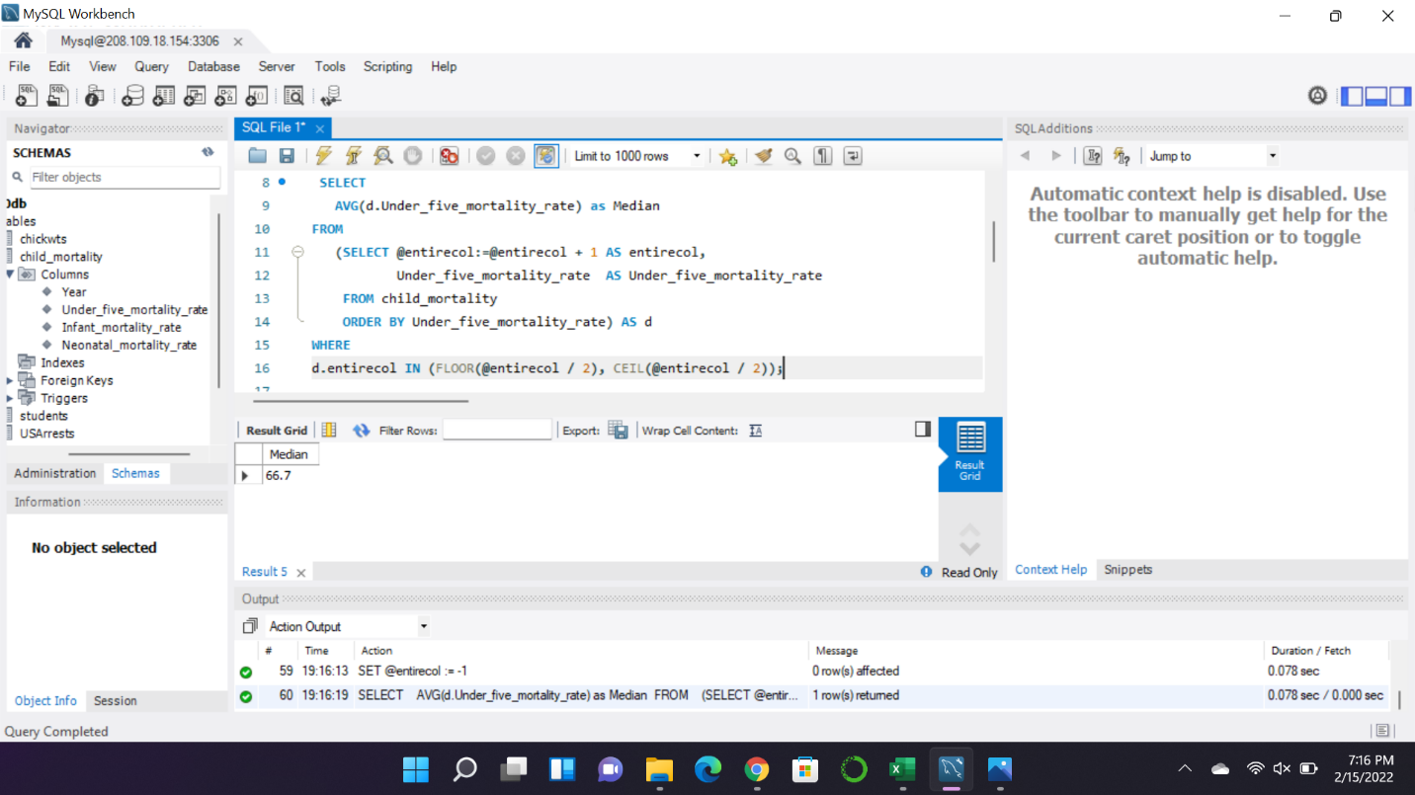

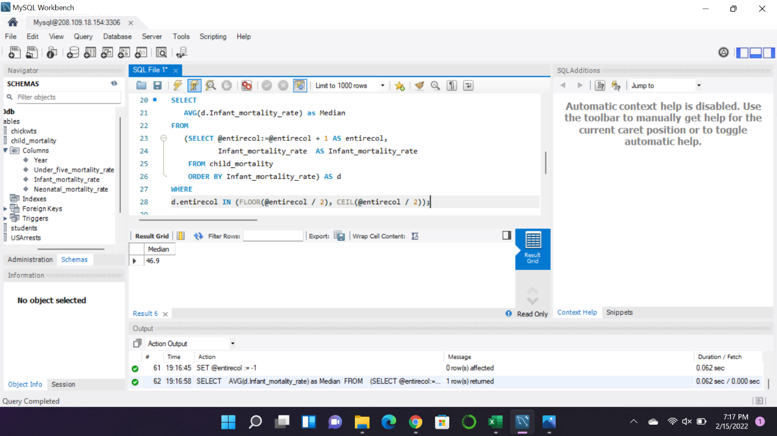

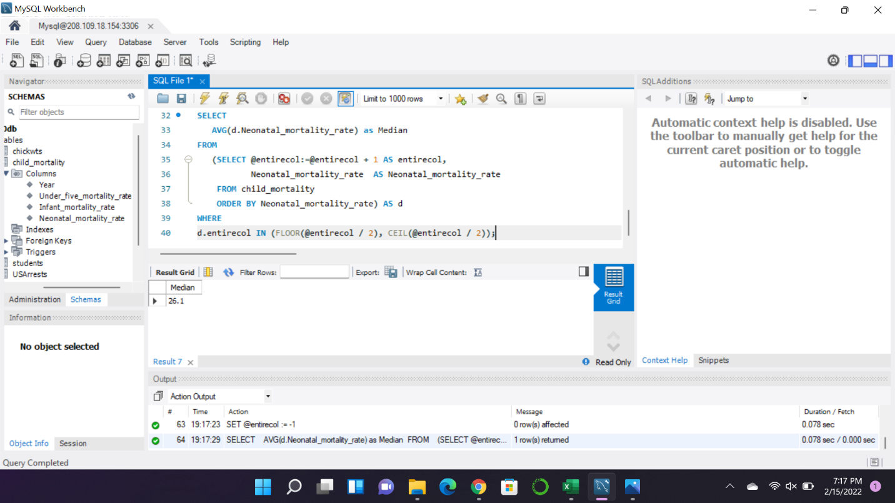

Display the entire table ;

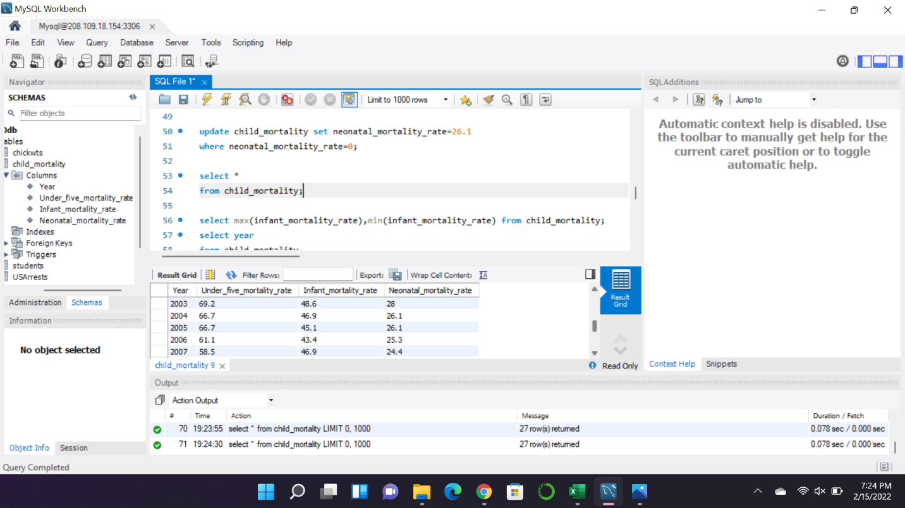

Which years have the lowest and highest infant mortality years, respectively?

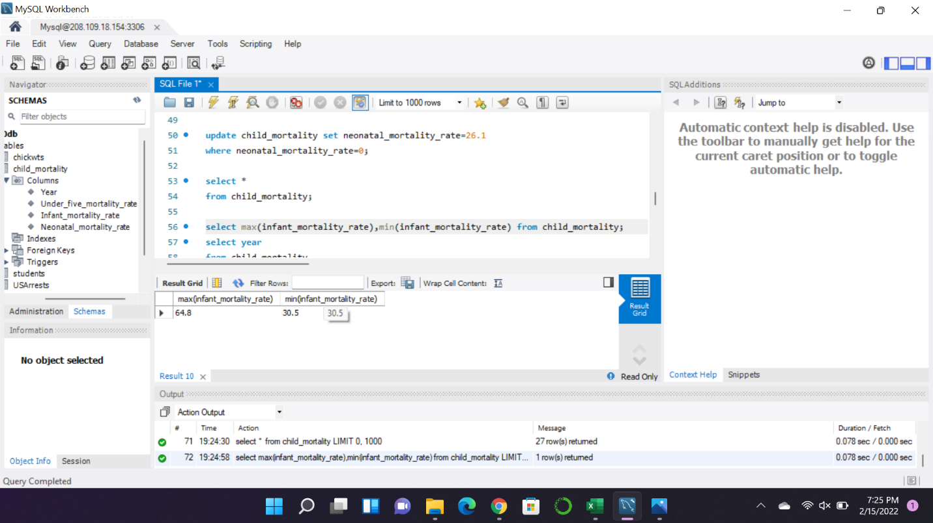

In what years the neonatal mortality rates were above average?

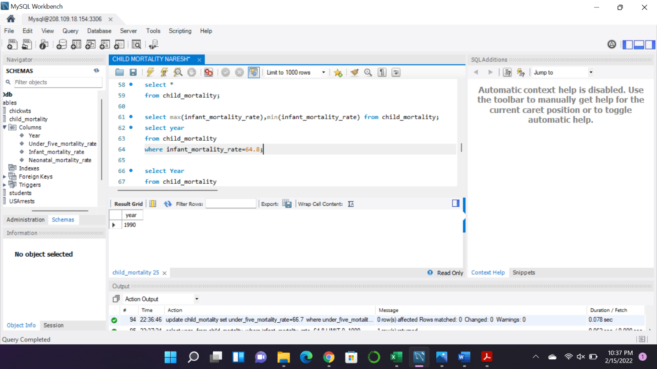

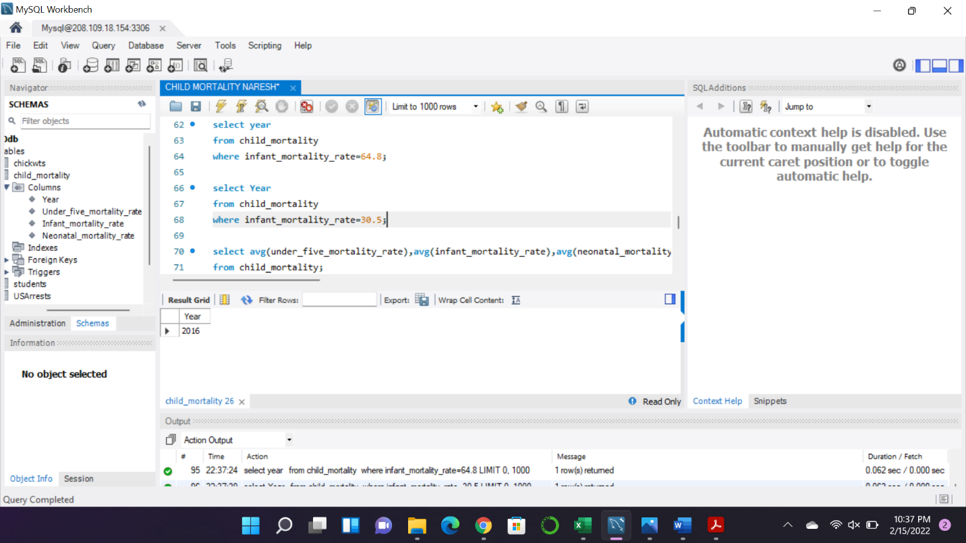

Display the sorted infant mortality rates in descending order.

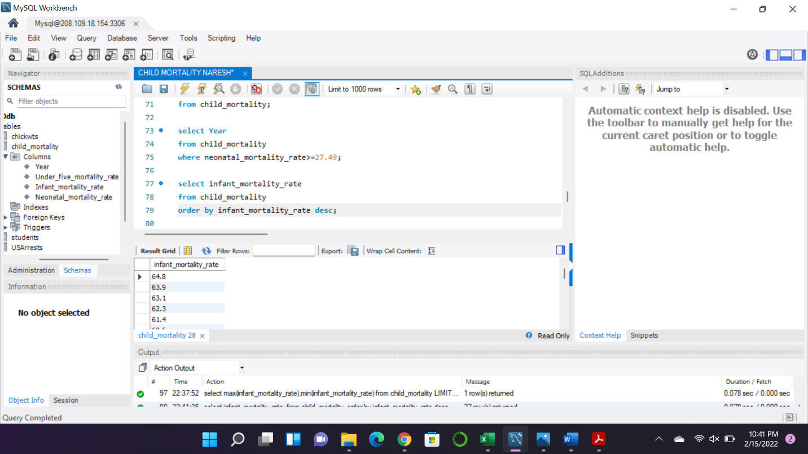

Display **min**, **max**, **mean**, **variance**, and **standard deviation** for each mortality rate.

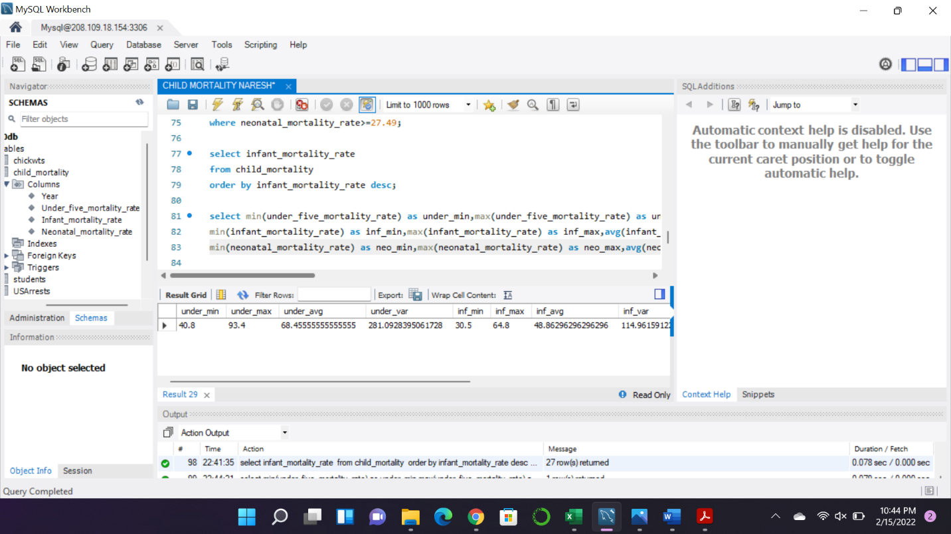

Add a new column called **Above-Five Mortality Rate** and populate it with appropriate values.

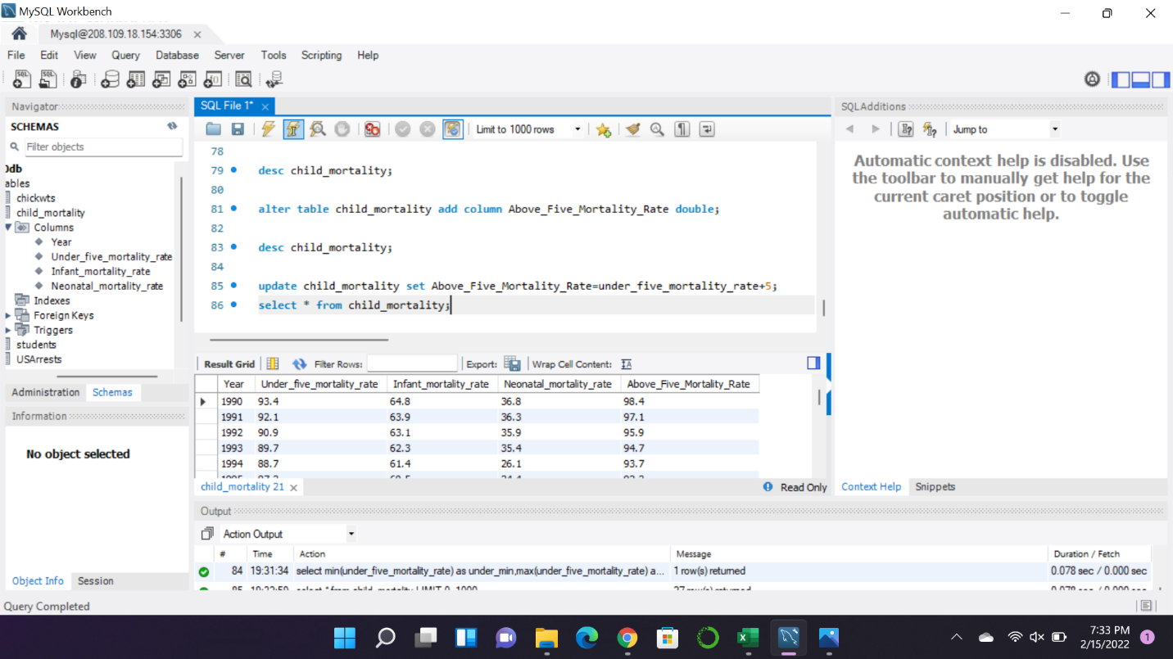

Display the entire table again.

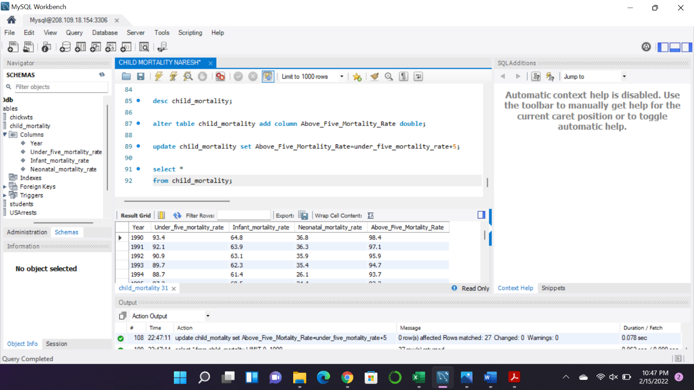

Excel Worksheets: Problem 1:

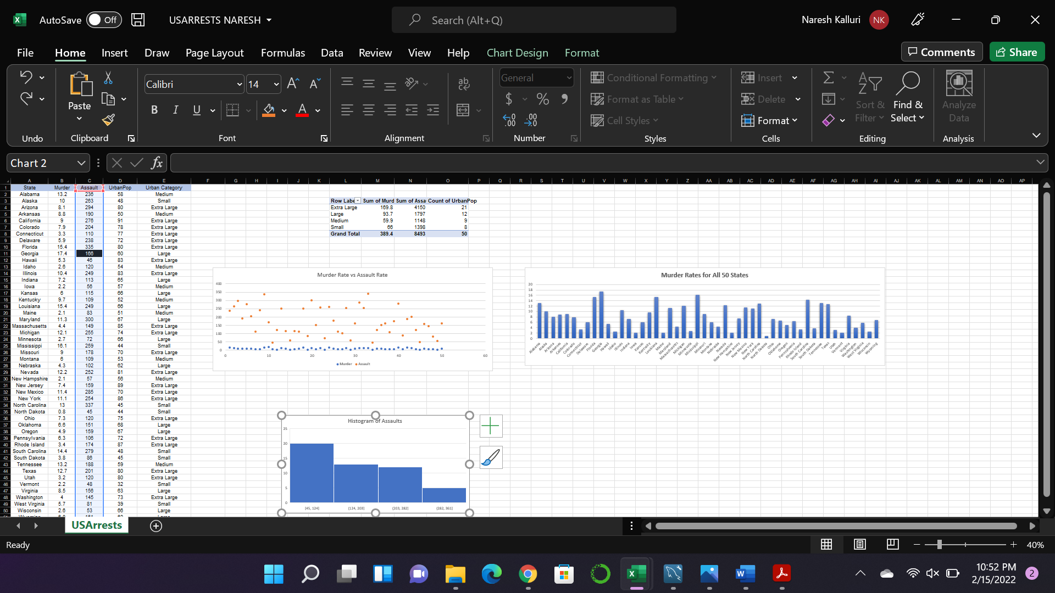

Problem 2:

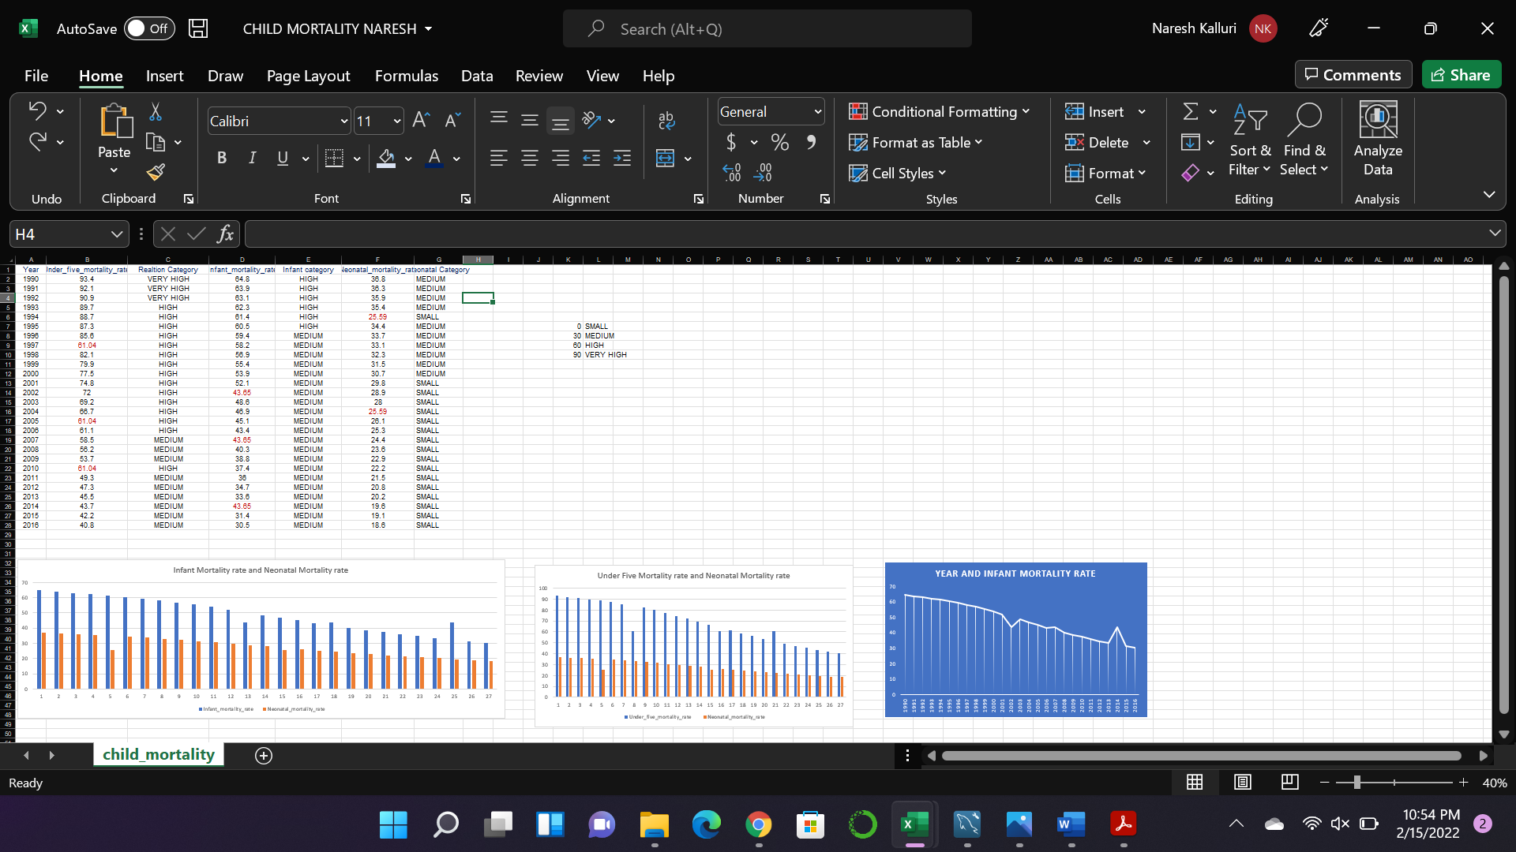

References:

<https://www.geeksforgeeks.org/calculate-median-in-mysql/>

Used for how to calculate Median in MySQL

I converted my cleansed data into XML and JSON formats and uploaded it to my GitHub repository including my Excel Worksheets.